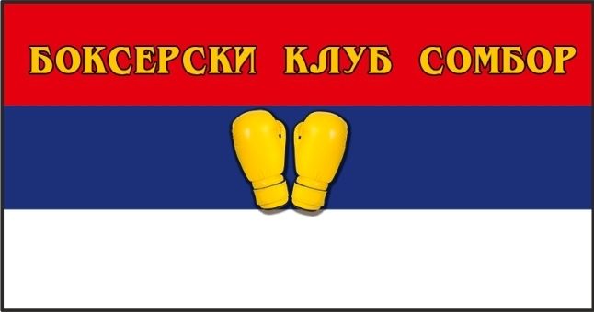13th NATIONS CUP – WOMEN’S

14–22 January, 2024 in Sombor , Serbia

PRELIMINARY ENTRY FORM
--Please return this form not later than ‚05th of December, 2023-

Association or Federation of: ________________________________________________

DELEGATION COMPOSITION:

Team Leader | Medical | Other | R/J | Coach | Boxers | Total

Selected accommodation | Hotel BARCODE  SPA ****+ | Hotel Andrić **** | Hotel Stari Slon ***  Hotel Knez Petrol ***  Aparaments Galea ***  Guesthouse Karibo ***  Vila Tamara ***  Hotel Old Brice***  Aparaments Gren Town*** | Students Dorms Sombor*  Students Dorms Apatin *

SCHOOLGIRLS BOXERS

MEMBER
34-36 kg | 38 kg | 40 kg | 42 kg | 44 kg | 46 kg | 48 kg | 51 kg | 54 kg | 57 kg | 60 kg | 64 kg | 70 kg

JUNIOR GIRLS BOXERS

MEMBER
44-46 kg | 48 kg | 50 kg | 52 kg | 54 kg | 57 kg | 60 kg | 63 kg | 66 kg | 70 kg | 75 kg | 80 kg | +80 kg

YOUTH GIRLS BOXERS

MEMBER
45-48 kg | 50 kg | 52 kg | 54 kg | 57 kg | 60 kg | 63 kg | 66 kg | 70 kg | 75 kg | 80 kg | +80  kg

ELITE WOMEN BOXERS
45-48 kg | 50 kg | 52 kg | 54 kg | 57 kg | 60 kg | 63 kg | 66 kg | 70 kg | 75 kg | 80 kg | +80  kg

MEMBER

( City and Date ) (Stamp) President or General Secretary

